## l

**Merchant:** [Sprinto](https://app.hubspot.com/contacts/43610657/record/0-2/23760518152)

Demo date: Oct 25, 2024  
Scoping start date: Oct 25, 2024

MSA Signature Date: Dec 16, 2024  
Onboarding Kick Off Date: Dec 19, 2024

[If Exists] Opt Out Date:  
Go Live Date: Jan 31, 2025

GTM POC: Shaun  
Implementation POC: Royce (Deepak / Arjun involved during motion)

ERP: QBO Zoho for India

Tax Integration: No Tax Avalara planned for US, Manual GST config for India

### 

### Key people at Merchant

* Director of Finance (Main POC): [Naga Subramanya](https://app.hubspot.com/contacts/43610657/record/0-1/66433098645?eschref=%2Fcontacts%2F43610657%2Frecord%2F0-3%2F23143642540)

### Customer service rep who is really involved: Himani

* Account Receivable POC: [Kashyap Shettigar](https://app.hubspot.com/contacts/43610657/record/0-1/70635751317?eschref=%2Fcontacts%2F43610657%2Frecord%2F0-2%2F23760518152) (
* Billing POC: Naga Subramanya

### Etc.

### 

| Notes Sections [Ops International Team to Ignore] *(AE/ Implementation to fill)*  **Info on how merchant bills:**   * Standard SaaS billing model. * 70% annual upfront payments; remainder split into half-yearly or quarterly terms. * Bespoke terms added directly into order forms. * Indian entity invoices Indian customers in INR; US entity invoices globally in USD.   **Spreadsheets related to implementation:**   * Current manual spreadsheets are used for:   + AR aging   + Cash forecasting   + Custom revenue recognition   + Non-GAAP metrics   **Important Merchant Relationship Information:**   1. **Merchant Temperament:**    * Stakeholders are engaged but cautious due to critical system reliance.    * Previous implementation (Unim) took 6+ months, resulting in hesitation. 2. **Key POC / Decision Maker:**    * **Naga Subramanya** 3. **Tabs Features That Key POC Cares About:**    * Full automation of post-close workflows (HubSpot -> Tabs -> ERP).    * AI-driven contract ingestion and revenue reporting.    * **Cash Forecasting**: Biggest pain point.    * Custom AR flexibility (e.g., Dunning, reminders, tax logic).    * Integration capabilities (Avalara, HubSpot, Zoho).    * Reporting: Ability to customize ARR metrics and cross-sell/price increase reporting. |
| --- |

### Company summary *(AE to fill)*

Sprinto is a fullstack security and compliance automation platform. It continuously monitors, and collects evidence of a companys security controls, helping companies obtain and maintain compliances like SOC2, ISO 27001, GDPR, HIPAA and many more.

Goals (North star)  
*(AE/ Implementation to fill)*

Primary Goals:

* Replace manual workflows between HubSpot, Cacheflow, Unium, QBO, and Zoho.
* Achieve accurate and automated cash forecasting and AR reporting.
* Reduce human errors caused by disconnected systems.

Specific Issues:

* Manual checks between Cacheflow (sunsetting) and Unium create inefficiencies.
* Inadequate reporting capabilities in Unium.
* No Avalara integration; India taxes are manually configured.
* Limited visibility into multi-product revenues.

### Billing model *(AE/ Implementation to fill)*

* **Current Setup:**
  + Fixed SaaS pricing with annual and multi-period terms.
  + No current usage-based billing but it is anticipated in the future.

**Unique Aspects:**

* Multi-currency support (USD and INR).
* Separate ERPs for different entities (QBO for US, Zoho for India).
* Taxes are calculated manually as either 9%/9% or 18% based on Indian State

[Product spec doc](https://docs.google.com/document/d/11upc_8INGqj4swWqZnUKsaTspQrC5vByabQykWo-lH8/edit?tab=t.0)

### Contract Processing Steps *(Implementation/Success to fill)*

**[ashni to check on integration items]**

**Steps to process NEW Contracts:**

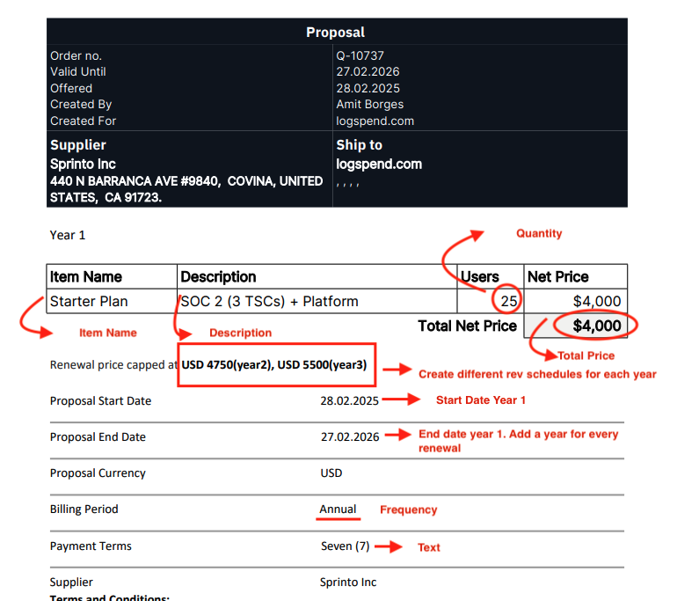

* [Garage Example here](https://garage.tabsplatform.com/prod/contracts/6456652f-157d-4674-8b1e-837256afbc8e/terms/revenue)
* Service Start Date: Listed in contract, the service start date will be in increments of one year if there is a renewal listed
* Months of Service: 12 if yearly service
* Item Name: listed in contract
* Integration Item: Startup Plan US if Starter Plan, if not search for closest match
* Billing type: Flat
* Total Price: Listed in contract for year 1, year 2 and year 3
* Quantity: number of users
* Start Date: Listed in contract for year 1, add one year for year 2, add another year for year 3
* Net Terms: listed in contract
* Frequency: listed in contract

1. Steps to process

**Always scroll to the bottom of the contract to find “Payment Schedule”**.

That section will guide you on how many rev schedules you should set up and the dates to put for Start Dates.

This should be your source of truth. See screenshot below of **Payment Schedule.**

This will tell you the dates, net terms, and how many revenue schedules you need to create. Create a revenue schedule for every line listed in the payment schedule.

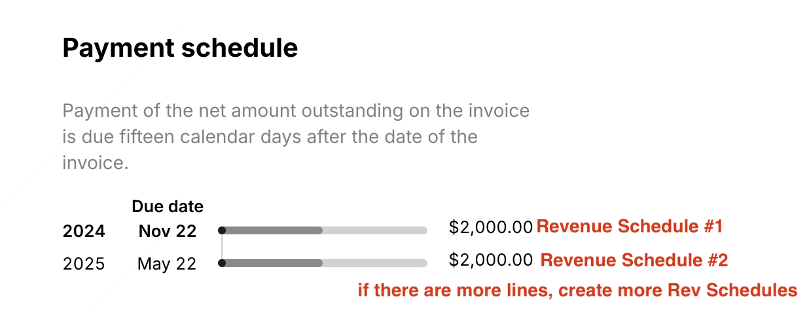

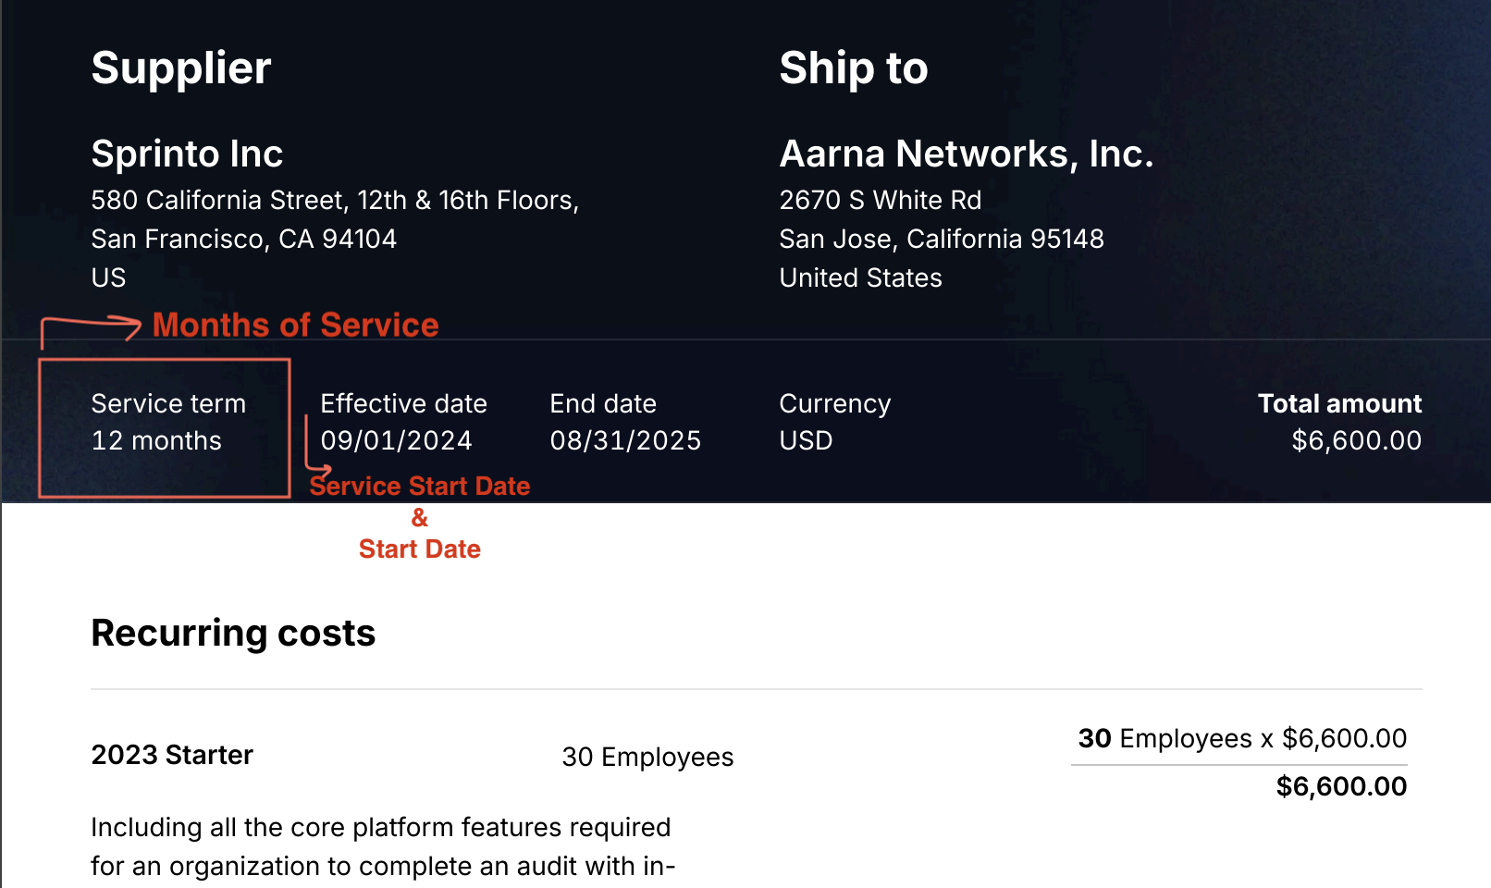

**Service Start Date**: See screenshot above as an example

**Total Months of Service**: Listed with Service Term

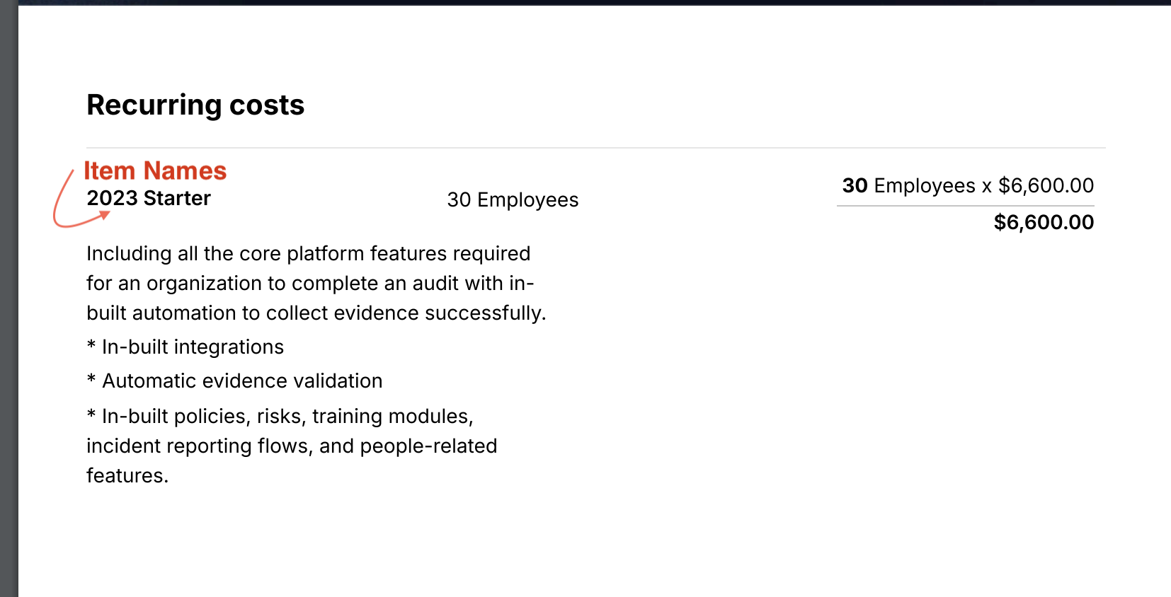

**Item Name**: Copy and Paste item name listed, example from screenshot above “2023 Starter”

**Billing Type**: Flat

**Total Price:** Found in contract. Refer to **Payment Schedule** section in the contract.

**Quantity:** Default 1

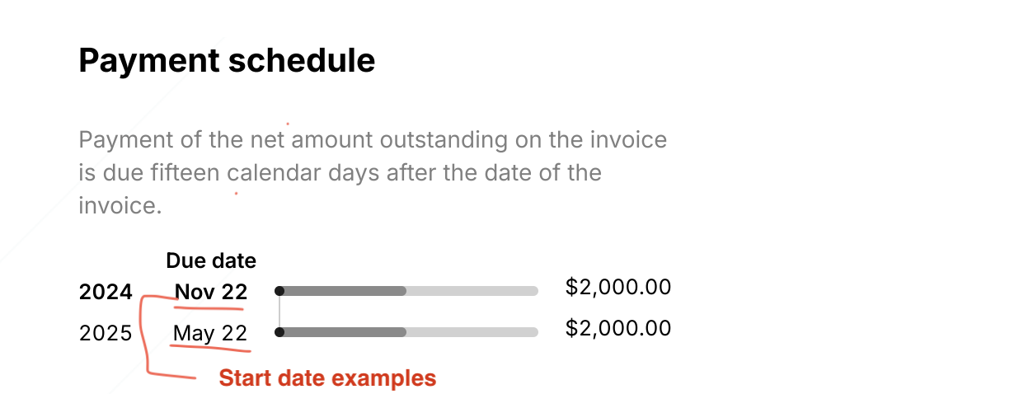

**Start Date:** Use the date listed in Payment Schedule listed for the corresponding line item

**Frequency:** None

**Net Terms:** Refer to information in Payment Schedule, if none listed default to 15

1. Anything to ignore in contracts?
2. Specifics processing things the merchant has requested that may differ by contract (e.g. always back-date invoice date to final day of the month)
3. Default Service Term
   1. If None Listed, Ops Default is 1 Year
4. Default Net Payment Terms
   1. Default 15
5. Default Billing Frequency
   1. If None Listed, Ops Default is Monthly
6. How do we handle taxes as a line item?
   1. If None Listed, Ops Default is every tax line item becomes a BT

### Renewals

1. Process all renewals on the contract denoting the renewal.

### Events Processing (if necessary) *(Implementation/Success to fill)*

* Any important information on events billing

Integration Items Processing (if necessary)  
*(Implementation/Success to fill)*

* What are the instructions for assigning integration items?
* Example: All Statsig integrations items should be labeled as “Sales”
* Example: All “Pinata” integration items should be labeled as “Software Subscription Bundle” unless otherwise noted by Merchant

Post Processing Communications (if necessary)  
*(Implementation/Success to fill)*

* Does the Ops Team need to notify anyone on the team re: completion of processing batches in Implementation or Active phase?
* Who needs to be notified and when?
  + Example:
    - Who: Customer Success [Azmat Aziz] needs to be notified
    - Where: Messari internal merchant channel
    - When: contracts are processed [Merchant Phase: Active]

### Customer Information *(Implementation/Success to fill)*

* Please add the billing and shipping information based on Ship To on the contract
* 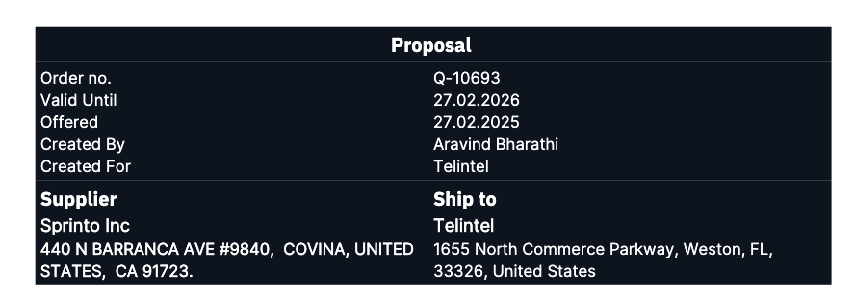

### Feature Requests *(AE/Implementation/Success to fill)*

[**Full Requirements doc**](https://docs.google.com/presentation/d/1pHUgZO4OAOm_jdGUI2I36Yd6tHaE7eJqWP8IgCgqT4w/edit#slide=id.g314efe4dde3_0_0)

* FR 1
  + What is it
  + Why it's important
  + Urgency

### Rewatch Calls *(AE/Implementation/Success to fill)*

* Oct 10th [Intro Call](https://tabs.rewatch.com/autocomplete/redirect_search?terms%5B%5D=Sprinto&url=%252Fvideo%252Fkmnkw7lnqq95fids-tabs-intro-call-sprinto-october-10-2024)
* Oct 25th [Custom Demo](https://tabs.rewatch.com/autocomplete/redirect_search?terms%5B%5D=Sprinto&url=%252Fvideo%252Fjclezhnqgef1gb4y-tabs-custom-demo-proposal-sprinto-october-25-2024)
* Nov 6th [Check in](https://tabs.rewatch.com/autocomplete/redirect_search?terms%5B%5D=Sprinto&url=%252Fvideo%252F2wgnzyxc5s520zhv-sprinto-tabs-touchbase-november-6-2024)
* Nov 12th [Prod discussion](https://tabs.rewatch.com/autocomplete/redirect_search?terms%5B%5D=Sprinto&url=%252Fvideo%252Fcthey2l6hipko482-tabs-x-sprinto-november-12-2024)
* Nov 20th [Check in](https://tabs.rewatch.com/autocomplete/redirect_search?terms%5B%5D=Sprinto&url=%252Fvideo%252F0vqgmnb68iemzd7w-sprinto-x-tabs-november-20-2024)
* Nov 21st [Prod discussion 2](https://tabs.rewatch.com/autocomplete/redirect_search?terms%5B%5D=Sprinto&url=%252Fvideo%252Fm9quhv9yambbbwgd-sprinto-tabs-november-21-2024)
* Nov 26th [Check in](https://tabs.rewatch.com/autocomplete/redirect_search?terms%5B%5D=Sprinto&url=%252Fvideo%252Fukqmms62jo184vri-sprinto-tabs-november-26-2024)
* Dec 5th [API](https://tabs.rewatch.com/autocomplete/redirect_search?terms%5B%5D=Sprinto&url=%252Fvideo%252Fjndwecr266zd19xl-sprinto-tabs-december-5-2024)
* Dec 6th [API 2](https://tabs.rewatch.com/autocomplete/redirect_search?terms%5B%5D=Sprinto&url=%252Fvideo%252Fvnsxf0e3f3xvtoef-sprinto-tabs-december-6-2024)
* Dec 10th [wrap up](https://tabs.rewatch.com/autocomplete/redirect_search?terms%5B%5D=Sprinto&url=%252Fvideo%252Fryama6gtnxv8rz71-sprinto-tabs-december-10-2024)